A000-Eur-Spain-Pasiega Cave-Mousterian-Neanderthal-Cobble hammer-Limestone-60,000 BP

**Case No.: 1**

**Accession Number:**

**Formal Label:**

Eur-Spain-Pasiega Cave-Mousterian-Neanderthal-Cobble hammer-Limestone-60,000 BP

**Display Description:**

**LC Classification:**

**Date or Time Horizon:**

**Geographical Area:**

**Map:**

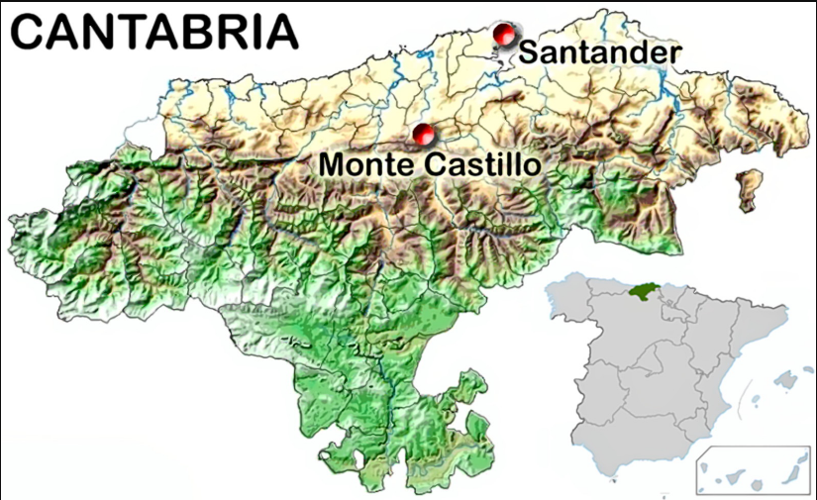

La Pasiega cave is one of the caves of Monte Castillo, the locality shown here, in northern Spain. Photo: [Hoffmann et al. (2018)](https://www.donsmaps.com/pasiegacave.html#reference)

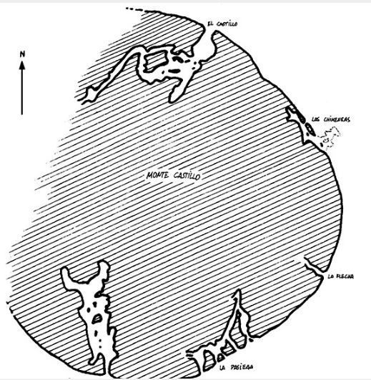

the caves of Monte Castillo northern Spain after [Hoffmann et al. (2018)](https://www.donsmaps.com/pasiegacave.html#reference)

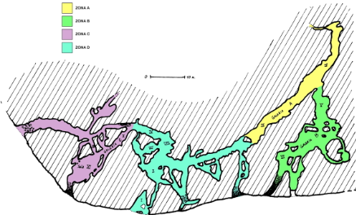

**Plan of La Pasiega cave in Spain.** Photo: José-Manuel Benito Álvarez —> Locutus Borg. Permission: GNU Free Documentation License, Version 1.2

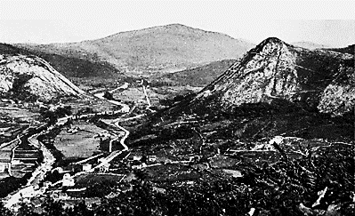

Valley of the Rio Pas at Puente Viesgo, Spain. Photo and text: [Dickson (1915)](https://www.donsmaps.com/pasiegacave.html#reference)

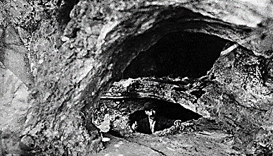

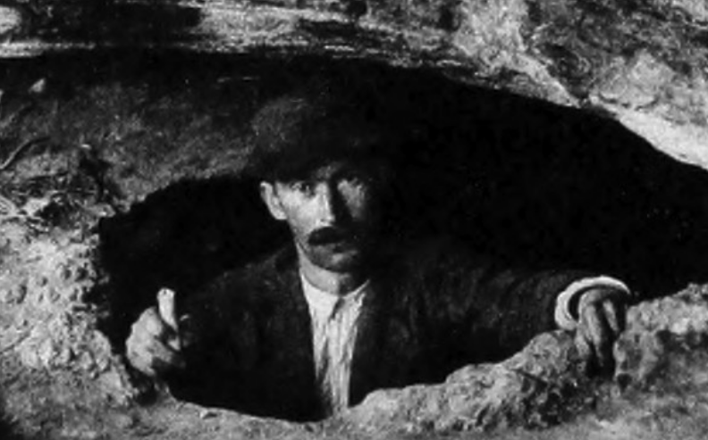

Entrance to La Pasiega circa 1911.   
  
Alejandro Mena Garay, foreman of Professor Obermaier and chief of the Spanish excavators is shown emerging from La Pasiega about 1911. He holds a candle in his hand which if it went out would have alerted him to the lack of oxygen thus signaling that the cave were unsafe for the excavators he managed. He is shown emerging from the cave long before this cave entrance, which was entered by Neanderthals c 60,000 ago was destroyed for the benefit of tourists in the 1930’s. (*Alejandro Mena Campuzano,* Alejandro Mena Garay’s *great grandson, provided this identification to Don Hitchcock for his superb website that he has managed for many years.* See https://www.donsmaps.com/images37/lapasiegapuentev00breu_orig_0081mancave.jpg) Photo: Obermaier, in [Breuil et al. (1913)](https://www.donsmaps.com/pasiegacave.html" \l "reference)

**GPS Coordinates:**

**Cultural Affiliation:**

**Medium:**

**Dimensions**:   
**Weight:**

**Provenance:**

**Condition:**

**Discussion:**

**References:**

**APPENDIX: ROCK ART**

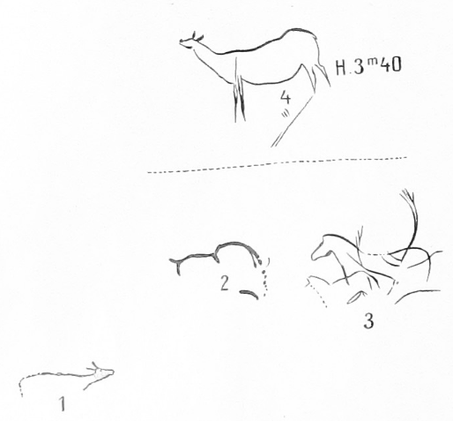

Left Panel

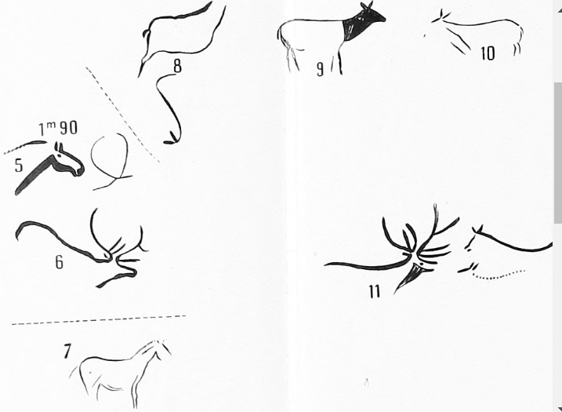 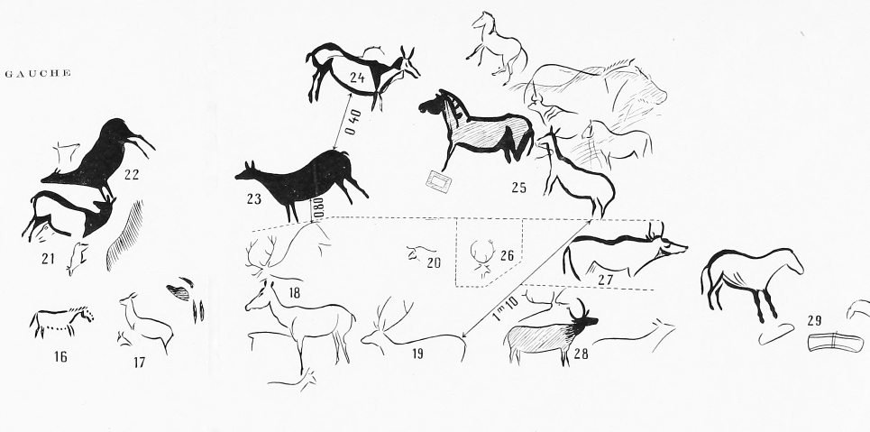

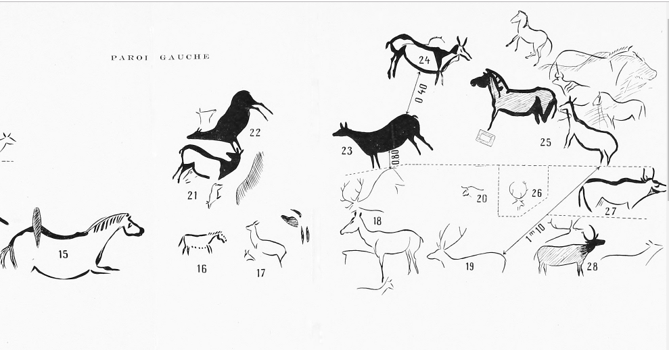



Various signs:   
  
1 bright purplish hue, located above the abyss, at no. 66.  
2 parallel engraved lines, at no. 66.  
3 group of red spots, at no. 46.  
4 small group of red spots, at no. 48.  
5 triple horizontal line at no. 60 of the plan.   
  
Photo and text: [Breuil et al. (1913)](https://www.donsmaps.com/pasiegacave.html" \l "reference)

Satellite photograph from Google Earth of the El Castillo site.   
  
The view has been tilted to indicate the local relief, with the cave complex on the limestone hill of Monte Castillo.   
  
Photo: Google Earth

Map of the Iberian Peninsula. The dots indicate the locations of three important cave sites.  
  
1: La Pasiega  
  
2: Maltravieso  
  
3: Ardales   
  
Photo: [Hoffmann et al. (2018)](https://www.donsmaps.com/pasiegacave.html#reference)

Plan of La Pasiega, 1913.   
  
Photo: [Breuil et al. (1913)](https://www.donsmaps.com/pasiegacave.html#reference)

Plate I.  
  
The end of Gallery A.   
  
Photo: Obermaier, in [Breuil et al. (1913)](https://www.donsmaps.com/pasiegacave.html" \l "reference)

Figures on the walls of Gallery A from La Pasiega.   
  
Photo and text: [Breuil et al. (1913)](https://www.donsmaps.com/pasiegacave.html" \l "reference)

Various signs:   
  
1 bright purplish hue, located above the abyss, at no. 66.  
2 parallel engraved lines, at no. 66.  
3 group of red spots, at no. 46.  
4 small group of red spots, at no. 48.  
5 triple horizontal line at no. 60 of the plan.   
  
Photo and text: [Breuil et al. (1913)](https://www.donsmaps.com/pasiegacave.html" \l "reference)

A group of large red claviform signs, situated at no. 58 on the plan, on the ceiling of a small chamber.   
  
( *note the striking resemblance to the venus figure engravings of Lalinde and Gönnersdorf, see below - Don*)  
  
Photo and text: [Breuil et al. (1913)](https://www.donsmaps.com/pasiegacave.html" \l "reference)

Engravings in the Lalinde style from la Roche de Lalinde, which bear a strking resemblance to the claviform signs of Pasiega Cave shown above.   
  
Photo: Don Hitchcock 2014  
Source: Original, Musée National de Préhistoire, Les Eyzies

Red symbols situated 4 metres above ground level, at no. 49 on the plan.   
  
It is a strange and incomprehensible thing that these mysterious characters have been drawn so high, in a place not very easy to access, and in a place that we would not easily discover.   
  
So often we can observe the search for small secluded recesses as narrow and out of the way as possible, as here. It must be said however, that the artist nevertheless had the wish to display these mysterious figures. It does not enter into our minds to seek to penetrate their meaning. We will only describe them simply, in a few words.

In the lower region, some irregularly arranged small lines and spots. On the right, a design similar to a capital E, but with a doubled small central bar. E-shaped figures are quite common on the coloured pebbles of Mas-d'Azil; we can also discover them on the ceiling of Altamira, but in black. In the upper region, two human feet on the right, with outlines drawn roughly and schematically, with one having four, the other five toes. A line joins the two heels.   
  
On the left, a figure very similar to certain tectiforms of Font-de-Gaume; there is the parallel line of a double floor, the single central stake, the side walls formed of two vertical lines; the arched doors, surmounted by a second arch, are barely different from those of Font de Gaume with an arch made of a double line. Only the roof is completely missing, and that voluntarily.  
  
In Marsoulas, too, there exists, in a panel rich in mysterious signs, tectiforms with and without roofs. Why this omission? This is a mystery that we will not attempt to solve.  
  
The inscription is certainly there, but it will never tell anyone its secret - a sign of prohibition, perhaps, with regard to the layman on the threshold of the sanctuary reserved for the initiates? We are unlikely to find out.   
  
Photo and text: [Breuil et al. (1913)](https://www.donsmaps.com/pasiegacave.html" \l "reference)

Sketches of the main types of Tectiformes of La Pasiega, grouped for their systematic study.   
  
Older series: 1 to 3.   
  
Primitive and shield shaped types: 4 to 25, second series.   
  
Photo and text: [Breuil et al. (1913)](https://www.donsmaps.com/pasiegacave.html" \l "reference)

Sketches of the more advanced Tectiforms of La Pasiega for their systematic study.   
  
( *note that the ladder shaped number 12, in red, from Salle XI, is now believed to have been painted by Neandertals, see below - Don*)   
  
Photo and text: [Breuil et al. (1913)](https://www.donsmaps.com/pasiegacave.html" \l "reference)

Gallery B.  
  
Early Magdalenian drawing showing a doe and a caprid (goat), situated at location 57.   
  
( *note also the distinctive dorsal outline of a mammoth at the top left - Don*)  
  
Photo and text: [Breuil et al. (1913)](https://www.donsmaps.com/pasiegacave.html" \l "reference)

Gallery B.  
  
Small drawings at locations 45 and 57.   
  
( *possibly a doe on the left and ibex on the right - Don*)  
  
Photo and text: [Breuil et al. (1913)](https://www.donsmaps.com/pasiegacave.html" \l "reference)

Gallery B.  
  
Black deer, incompletely conserved, situated at position 59 of the complete plan of the drawings of La Pasiega.   
  
Photo and text: [Breuil et al. (1913)](https://www.donsmaps.com/pasiegacave.html" \l "reference)

Gallery B.  
  
Eyes engraved here and there near accidental marks on a rough and cracked wall, at no. 57 of the plan transform these accidents into figures. The one on the right is certainly a horse, the sinuous lines are natural.   
  
Photo and text: [Breuil et al. (1913)](https://www.donsmaps.com/pasiegacave.html" \l "reference)

Gallery B.  
  
Small horse painted in red (no. 50 on the plan) and an ibex of the same colour, with the haunches engraved (no. 47 on the plan)   
  
Photo and text: [Breuil et al. (1913)](https://www.donsmaps.com/pasiegacave.html" \l "reference)

Gallery B.  
  
Small engraved horses, at nos. 50 and 55 on the plan.   
  
Photo and text: [Breuil et al. (1913)](https://www.donsmaps.com/pasiegacave.html" \l "reference)

Gallery B.  
  
Small engraved horse, no. 50 on the plan.   
  
( *Thus there are three different engravings/paintings of horses, all numbered as number 50 in the text - Don*)  
  
Photo and text: [Breuil et al. (1913)](https://www.donsmaps.com/pasiegacave.html" \l "reference)

**Gallery C consists of Salles VII, VIII, IX, X and XI.**

Red scalariform (ladder shaped) sign, panel 78 in Salle XI of La Pasiega gallery C. This panel features the La Trampa pictorial group (21). (Inset) Crust sampled and analysed for a minimum age (64 800 BP), which constrains the age of the red line. This is the first direct evidence of art from Neandertals.   
  
Photo: [Hoffmann (2018)](https://www.donsmaps.com/pasiegacave.html#reference)

This excellent photo shows the scalariform sign in its local environment.   
  
Photo: http://wksu.org/post/cave-art-may-have-been-handiwork-neanderthals

La Pasiega C, rectangular, scalariform motif with incomplete zoomorphs and red dots on Panel 78.  
  
(left) Photo of the motif.  
  
(right) Drawing by Breuil.   
  
(*note that only the ladder shaped image is thought to be by Neandertals. The other images are probably later additions - Don* )   
  
Photo and text: [Hoffmann et al. (2018)](https://www.donsmaps.com/pasiegacave.html#reference)

Sampling details for PAS 34.   
  
(a) Scalariform motif; the black rectangle denotes the area enlarged in (b).   
  
(b) The scalpel points onto the carbonate crust before sampling.   
  
(c) The carbonate crust after the surface was scraped for initial cleaning.   
  
(d) The carbonate crust after sampling, red pigment is visible in the centre, clearly underlying the remaining carbonate.   
  
Photo and text: [Hoffmann et al. (2018)](https://www.donsmaps.com/pasiegacave.html#reference)

Gallery C.  
  
Plan of Salle XI, principal location of the wall paintings in Gallery C, with details of the positions of the panels.   
  
Photo and text:[Breuil et al. (1913)](https://www.donsmaps.com/pasiegacave.html#reference)

Gallery C.  
  
Black paintings from Gallery C, representing:  
  
90: the horns of an ibex.  
86: the dorsal line of a mammoth (?)  
89: a small bison.  
67: a group of ibex, the rightmost of which has undergone the curious addition of a second ibex head looked at from behind, and using the horns of the first as a neck.   
  
Photo and text: [Breuil et al. (1913)](https://www.donsmaps.com/pasiegacave.html" \l "reference)

Gallery C.  
  
Black paintings from Gallery C, representing a bison and aurochs, no. 88 from the plan.   
  
Photo and text: [Breuil et al. (1913)](https://www.donsmaps.com/pasiegacave.html" \l "reference)

Gallery C.  
  
Horse outlined in black, with another finely engraved, number 70 on the plan.   
  
Photo and text: [Breuil et al. (1913)](https://www.donsmaps.com/pasiegacave.html" \l "reference)

Gallery C.  
  
Engravings and black, incomplete lines depict horses, at no. 69, not marked on the plan.   
  
Photo and text: [Breuil et al. (1913)](https://www.donsmaps.com/pasiegacave.html" \l "reference)

Gallery C.  
  
Complex panel, engraved and painted, number 86 on the plan. The red claviform signs (horizontally striated) are the oldest; the black outlines overlay these, and are themselves intersected by engravings.   
  
Photo and text: [Breuil et al. (1913)](https://www.donsmaps.com/pasiegacave.html" \l "reference)

Gallery C.  
  
Panel of engravings, Aurignacian in character, located at 61 and 62 on the plan in Salle VII, located between Gallery A and Gallery C, but nominally attributed to Gallery C. They are accompanied by some red dots.   
  
Photo and text: [Breuil et al. (1913)](https://www.donsmaps.com/pasiegacave.html" \l "reference)

Gallery C.  
  
Bison engraved in the upper Aurignacian style, located at 88 on the plan.   
  
Photo and text: [Breuil et al. (1913)](https://www.donsmaps.com/pasiegacave.html" \l "reference)

Gallery C.  
  
Engraved horses recalling the Aurignacian engravings of the cave of Hornos de la Pena. Situated at 63 on the plan.   
  
Photo and text: [Breuil et al. (1913)](https://www.donsmaps.com/pasiegacave.html" \l "reference)

**Plates**

Plate II.   
  
Red or yellow horses distributed at various points of Galleries A and C.   
  
Photo and text: [Breuil et al. (1913)](https://www.donsmaps.com/pasiegacave.html" \l "reference)

Plate III.   
  
Red horses from Gallery A.   
  
A - No 44 cf. Pl II.  
B - No 3 cf. Pl VIII.  
C - No 25 very deformed cf. Pl XVI.   
  
Photo and text: [Breuil et al. (1913)](https://www.donsmaps.com/pasiegacave.html" \l "reference)

Plate IV.   
  
Panel of does in plain red, and doe No 4.   
  
Photo and text: [Breuil et al. (1913)](https://www.donsmaps.com/pasiegacave.html" \l "reference)

Plate V.   
  
Top - Plain red doe No 22, cf. Pl. IV.  
  
Bottom - Red doe No 21, cf. Pl. IV.   
  
Photo and text: [Breuil et al. (1913)](https://www.donsmaps.com/pasiegacave.html" \l "reference)

Plate VI.   
  
Top - Panel of does and deer, Gallery A.  
  
Bottom - Red or yellow does distributed at various points of Galleries A and C.   
  
Photo and text: [Breuil et al. (1913)](https://www.donsmaps.com/pasiegacave.html" \l "reference)

Plate VII.   
  
Top left - Red doe No 24, cf. Pl. XVI.  
  
Top right - Red Deer and red doe No 18.  
  
Bottom - Red doe No 18, cf. Pl. VI.  
  
  
  
Photo and text: [Breuil et al. (1913)](https://www.donsmaps.com/pasiegacave.html" \l "reference)

Plate VIII.   
  
Top - Red and yellow deer situated at various points of Gallery A.   
  
Bottom - Panel at the end of Gallery A.  
  
Photo and text: [Breuil et al. (1913)](https://www.donsmaps.com/pasiegacave.html" \l "reference)

Plate IX.   
  
Red and yellow deer.  
  
A - Red deer no 11, cf. Pl. VIII.  
  
B - Yellow deer no. 6, cf. Pl. VIII.  
  
C - Red deer no. 41, cf. Pl. VIII.  
  
Photo and text: [Breuil et al. (1913)](https://www.donsmaps.com/pasiegacave.html" \l "reference)

Plate X.   
  
Tectiform signs from Gallery A.  
  
Photo and text: [Breuil et al. (1913)](https://www.donsmaps.com/pasiegacave.html" \l "reference)

Plate XI.   
  
Panels Nos 34, 35, with animals and tectiforms, red or brown.  
  
Photo and text: [Breuil et al. (1913)](https://www.donsmaps.com/pasiegacave.html" \l "reference)

Plate XII.   
  
Top - Horse and bison, Nos 34, 35, cf. Pl. XI.  
  
Bottom - Red bull no. 28, cf. Pl. VIIII.  
  
Photo and text: [Breuil et al. (1913)](https://www.donsmaps.com/pasiegacave.html" \l "reference)

Plate XIII.   
  
Chamois, deer, horse and red tectiforms from Gallery A.   
  
Photo and text: [Breuil et al. (1913)](https://www.donsmaps.com/pasiegacave.html" \l "reference)

Plate XIV.   
  
Left top - Panel of tectiforms No 33, cf. Pl X, seen in a recess in which they lie hidden.   
  
Right top - Chamois No 36, cf. Pl. XIII.  
  
Right lower - Reddish brown horse No 43, cf. Pl. II.  
  
Bottom - Red bull no. 2, cf. Pl. XVIIII.  
  
Photo and text: [Breuil et al. (1913)](https://www.donsmaps.com/pasiegacave.html" \l "reference)

Plate XV.   
  
Deer, Bison and tectiforms from Gallery A.   
  
Photo and text: [Breuil et al. (1913)](https://www.donsmaps.com/pasiegacave.html" \l "reference)

Plate XVI.   
  
Horses, does, and bison from Gallery A.   
  
Photo and text: [Breuil et al. (1913)](https://www.donsmaps.com/pasiegacave.html" \l "reference)

Plate XVII.   
  
Top - Black horses No 25, cf. Pl XVI, right section.   
  
Bottom - Red doe and black horse No. 25, cf. Pl. XVI.  
  
Photo and text: [Breuil et al. (1913)](https://www.donsmaps.com/pasiegacave.html" \l "reference)

Plate XVIIII.   
  
Bulls, bisons etc., distributed between Galleries A and C.   
  
Photo and text: [Breuil et al. (1913)](https://www.donsmaps.com/pasiegacave.html" \l "reference)

Plate XIX.   
  
Red horse and bisons Nos. 51 and 53, Gallery B.   
  
Photo and text: [Breuil et al. (1913)](https://www.donsmaps.com/pasiegacave.html" \l "reference)

Plate XX.   
  
Red horses, Nos. 50 and 56, Gallery B.   
  
Photo and text: [Breuil et al. (1913)](https://www.donsmaps.com/pasiegacave.html" \l "reference)

Plate XXI.   
  
Red bison.   
  
Photo and text: [Breuil et al. (1913)](https://www.donsmaps.com/pasiegacave.html" \l "reference)

Plate XXII.   
  
Above - Large red horse No. 56, cf. Pl. XX.   
  
Below - Large red bison No. 54, cf. Pl. XXI.   
  
Photo and text: [Breuil et al. (1913)](https://www.donsmaps.com/pasiegacave.html" \l "reference)

Plate XXIII.   
  
Signs and animals of Salle XI.   
  
Photo and text: [Breuil et al. (1913)](https://www.donsmaps.com/pasiegacave.html" \l "reference)

Plate XXIV.   
  
Above - Symbolic inscription in red, No. 49 from Gallery B, cf. fig.20.   
  
Below (left) - Rock formation in the form of a throne, from Salle XI.   
  
Below (right) - Anthropomorphic head in red crowned by the horns of a bison, no. 77, cf. Pl. XXIII.   
  
Photo and text: [Breuil et al. (1913)](https://www.donsmaps.com/pasiegacave.html" \l "reference)

Plate XXV.   
  
Complex panel from Salle XI, with signs and animals.   
  
Photo and text: [Breuil et al. (1913)](https://www.donsmaps.com/pasiegacave.html" \l "reference)

Plate XXVI.   
  
Above - Engraved bison No. 88, cf. fig. 10.   
  
Below (left) - Red signs No. 74, cf. Pl XXV.   
  
Below (right) - Red claviforms no. 81, cf. Pl. XXIII.   
  
Photo and text: [Breuil et al. (1913)](https://www.donsmaps.com/pasiegacave.html" \l "reference)

Plate XXVII.   
  
Above - Reddish violet doe No. 74 - 75.   
  
Below - Bright red doe No. 82.   
  
Photo and text: [Breuil et al. (1913)](https://www.donsmaps.com/pasiegacave.html" \l "reference)

Plate XXVIII.   
  
Left - red does obliterated by black drawings restored to polychrome figures.  
  
Right - Brown bison subsequently restored with black.   
  
Photo and text: [Breuil et al. (1913)](https://www.donsmaps.com/pasiegacave.html" \l "reference)

Plate XXIX.   
  
Above - Brown bison restored with black, No. 83, cf. Pl. XXVIII.   
  
Below - Black bison No. 88, cf. Fig. 6.   
  
Photo and text: [Breuil et al. (1913)](https://www.donsmaps.com/pasiegacave.html" \l "reference)

**References**

1. **Alcalde del Rio H., Breuil H. & Sierra L.**, 1912: *Les cavernes de la région cantabrique*, Monaco, Vve A. Chêne, 265 p.
2. **Breuil, H., Obermaier, H., Alcalde Del Rio, H.**, 1913: *La Pasiega à Puente-Viesgo (Santander) (Espagne)*, Imprimerie Artistique Vve A. Chêne, 1913
3. **Breuil, H.**, 1921: Nouvelles cavernes ornées paleolithiques dans la province de Málaga, *L'Anthropology*, T. XXXI, no. 34. Paris.
4. **Cantalejo P., Ramos J., Weniger G., Kehl M., del Mar Espejo M.**, 2014: Cueva de Ardales, Province of Malaga, Southern Mediterranean Coast, Guadalquivir River and Betic Intramontane Basins, *Pleistocene and Holocene Hunter-Gatherers in Iberia and the Gibraltar Strait: The Current Archaeological Record*, Universidad de Burgos 2014
5. **Dickson M.**, 1915: *The American Museum Journal*, Volume XV, 1915, NYC.
6. **Hoffmann, D., et al.**, 2018: U-Th dating of carbonate crusts reveals Neandertal origin of Iberian cave art, *Science*, 359 (6378), 912-915. DOI: 10.1126/science.aap7778, pp. 912–915 (2018) 23 February 2018